Data Visualisation
Key Insights from the Apple Stock Dashboard
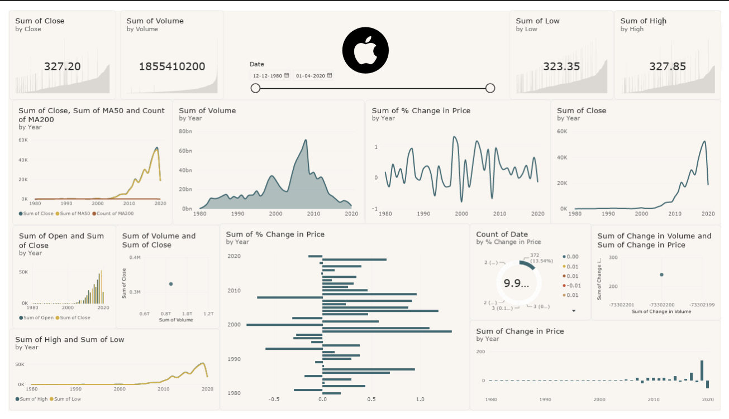
- Strong long-term price growth: Apple’s stock price remained relatively low and stable for many years, but showed a strong upward trend after around 2005, with a major increase during the 2010s.
- Peak in the late 2010s: The closing-price trend reaches its highest level around 2018–2019, followed by a noticeable decline toward 2020.
- High trading activity: Trading volume increased significantly over time and reached its highest level around the late 2000s, indicating periods of strong market activity.
- High and low prices move together: The High and Low price charts follow a very similar pattern, showing that both moved upward as the stock price increased.
- Opening and closing prices are closely related: The Open and Close values generally follow the same trend, indicating that the stock maintained a consistent overall upward movement over the long term.
- Daily percentage changes are volatile: The percentage-change chart fluctuates above and below zero, showing that Apple experienced both positive and negative daily movements. Some periods show relatively large fluctuations, indicating higher volatility.
- Price changes become larger in later years: The Change in Price chart shows relatively small movements in earlier years but much larger movements in the later period, mainly because the stock price itself became much higher.
- Moving averages confirm the long-term trend: The Close, MA50, and MA200 trends broadly move upward together, supporting the observation of a long-term bullish trend.

